**AIRBNB Case Study**

**Methodology Document PPT 1 :**

In the case study we have used Jupiter notebook to perform analysis of the data, for data analysis and visualization.

**Analysis using Jupiter Notebook:** Data Set Used: AB_NYC.2019.csv

**Number of Rows:** 48895

**Number of Columns:** 16

**Step 1:**

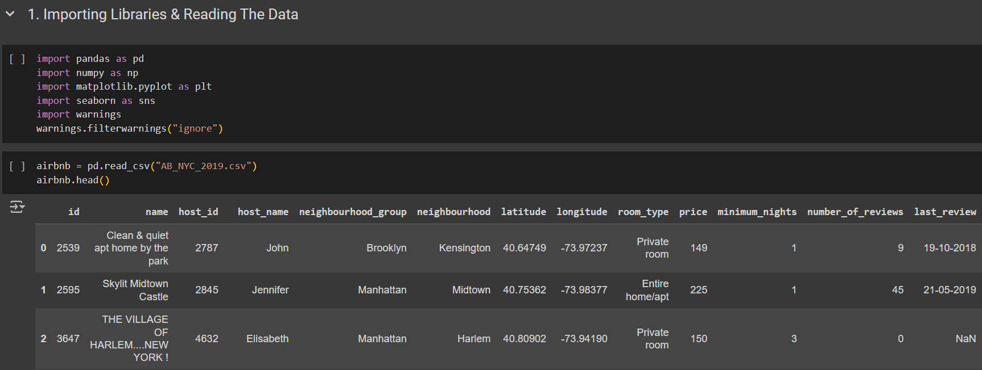

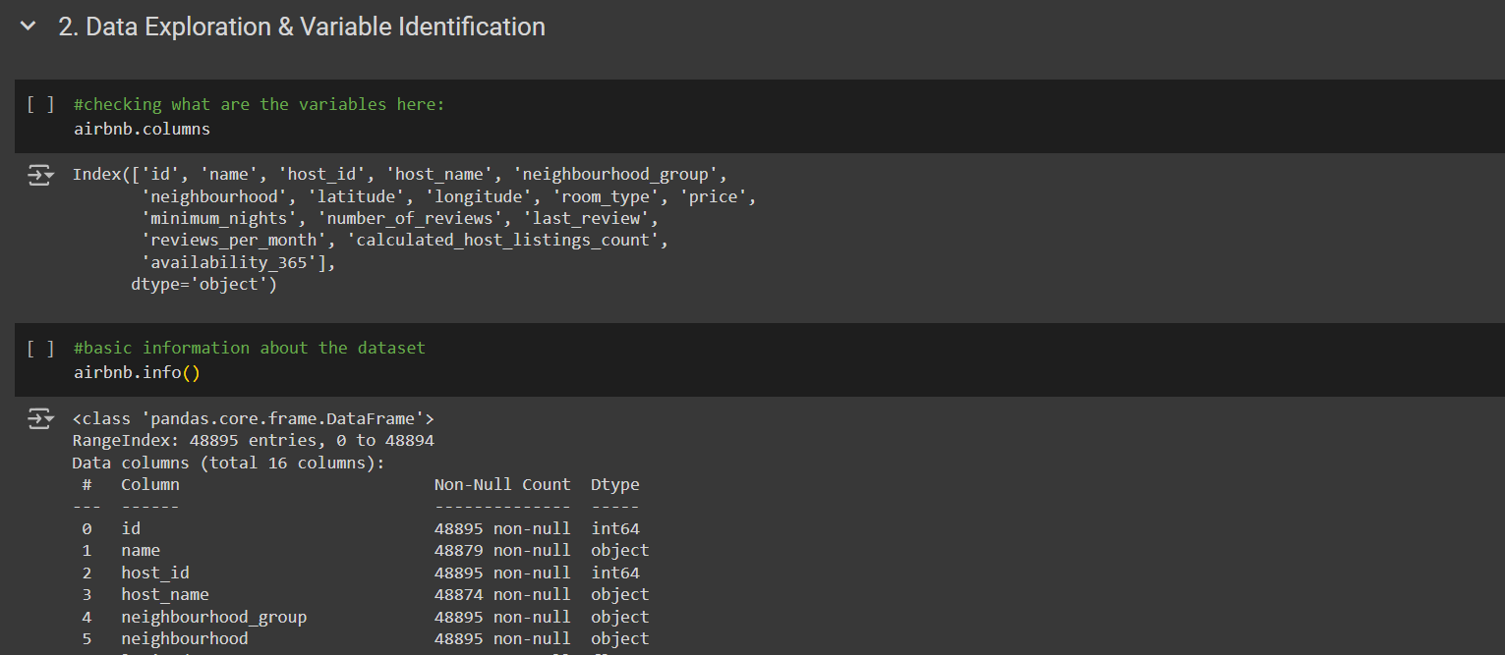





**Step 2: Data Wrangling**:

* Checked the Unique rows in different columns.
* Created Features using the columns as step of categorization.
* Did the Missing Value Analysis.
* Finally worked upon the Univariate, Bivariate and Multivariate Analysis.

**Step 3: Data Analysis and Visualizations:**

Below are the detailed steps used for each visualization.

1. Top 10 Host
2. Preferred Neighbourhood group
3. Preferred Room Type
4. Correlation among different columns
5. Review Category wrt Price
6. Room Type and Review Per Month
7. Availability 365 Category, Price Category and Review Per Month

**Methodology Document PPT 2 :**

1. **Top 10 Hosts**
2. **Popular Neighborhoods:**
   1. We created a pie chart for understanding the percentages of listings in different neighborhoods in NYC
3. **Preferred Room type:**
   1. We created a pie chart for understanding the percentage of room type preferred
4. **Reviews as per Minimum Night Categories:**
   1. We created a box plot for understanding the minimum night categories wrt number of reviews
5. **Reviews wrt Price and Availability**
   1. We grouped the data as per the Price and Availability Categories to understand the review ratings.